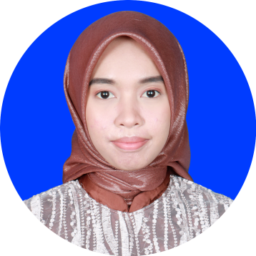

**NURUL INAYAH**

**Born**

Sengkang, May 21st 1998

**Address**

Jalan Andi Parenrengi, No.50, Sengkang, Kab. Wajo

**Phone**

081230233174

**Email**

[nurulinayah.a@gmail.com](mailto:nurulinayah.a@gmail.com)

**LinkedIn**

linkedin.com/in/nurul-inayah21

**Personal Info**

**Achievements**

* Selected as the **top 10** in the VOCOMfest 2018 mobile app development competition, as a **UI/UX**
* Webinar **speaker** on Youth Sharing Center (YSC)

**Skills (Professional)**

|  |  |  |  |  |  |  |  |  |  |  |
| --- | --- | --- | --- | --- | --- | --- | --- | --- | --- | --- |
| **SQL Server** |  |  |  |  |  |  |  |  |  |  |
| **PHP** |  |  |  |  |  |  |  |  |  |  |
| **HTML/CSS** |  |  |  |  |  |  |  |  |  |  |
| **Java** |  |  |  |  |  |  |  |  |  |  |
| **MS Word** |  |  |  |  |  |  |  |  |  |  |
| **MS PowerPoint** |  |  |  |  |  |  |  |  |  |  |
| **Figma** |  |  |  |  |  |  |  |  |  |  |

**Soft Skills**

* Time Management
* Team Work
* Leadership

**Experience**

March – May 2020

**UI/UX Designer Intern**

*Sinerbi Indonesia, Malang*

* Joining in a webinar to improve soft skills
* Creating UI for lecturer guidance apps

Sep – Dec 2019

**Laboratoy Assistant of Database System**

*Faculty of Computer Science (FILKOM) UB, Malang*

* Responsible for teaching all material both theory and practice based on module, about the basic of database system and how to use query language with Microsoft SQL Server and evaluating the practicum reports

Jun – Aug 2019

**Staff Intern**

*Badan Kesatuan Bangsa dan Politik, Malang*

* Responsible for creating Periodic Salary Increases system
* Responsible for collected archives of each department to create accountability report and check the suitability of programs that have been implemented

**Organizational Experience**

**Staff of Public Relation Department**

*Poros Organization of Open Source FILKOM UB, Malang*

* Responsible for manage twitter account and Open Source Info (OSI) of OS department
* Coordinate with other organizations in brawijaya university or open source communities in Malang to make visiting events

**Secretary**

*Poros Organization of Open Source FILKOM UB, Malang*

* Responsible for manage all incoming mails, create invite delegation, making event proposal and accountability report for all events related to Poros

Mar - Des 2019

Apr 2018 - Jan 2019

**Committee and Volunteer Experience**

**IT Volunteer**

*Youthoffers*

* Responsible for helps making a good application design, identifying problems that can be resolved through the youthoffers apps and follow the sharing session every week

Feb - Apr 2020

Sep - Nov 2018

**Head of Secretarial Division**

*Infromatic Project (IFP)*

* Responsible for making event proposal, accountability report, letter of invitation and meeting minutes

Jun - Okt 2018

**Secretary**

*Software Freedom Day (SFD)*

* Responsible for making sponsorship proposal, event proposal, accountability report, all list of attenden related to SFD, all letters related to SFD and meeting minutes

I am a last year student of Brawijaya University majoring in informatics engineering with GPA 3.41. Have an experience and skills in UI/UX, front-end web and management time through internship, competition, organization and volunteer opportunities. Looking for internship or job opportunities to increase my potential as well as deepen my interests in the IT field.